Cyclone V

Application Note

Table of Contents

QSys Integration 2

Instructions for programming Cyclone V PROM 6

# QSys Integration

When you saw the error messages in below, it means that you need to set “**IP Search Path**” in QSys.



Lunch QSys GUI in Menu **Tools\QSys**

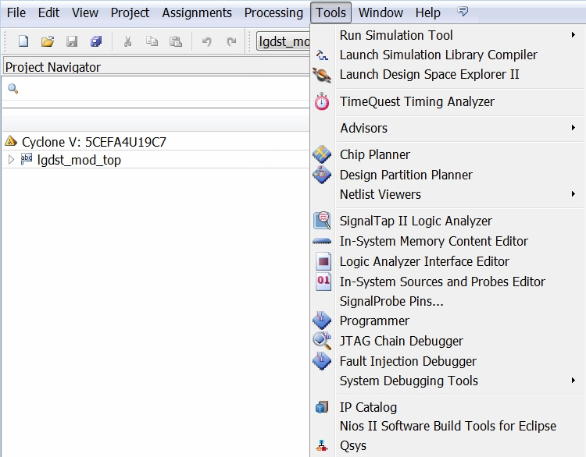

Open QSys file “system_bd.qsys”

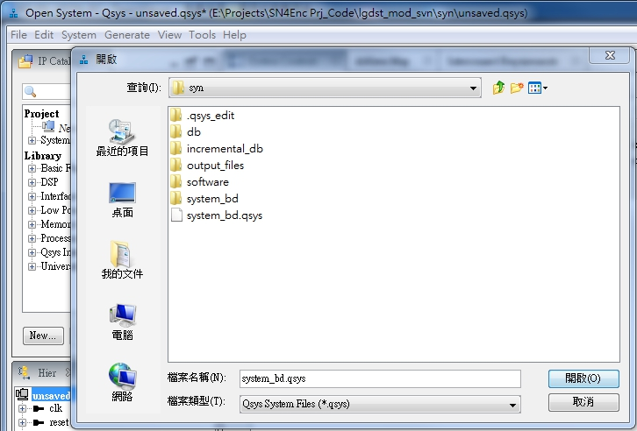

You will see the error messages for missing component ☹

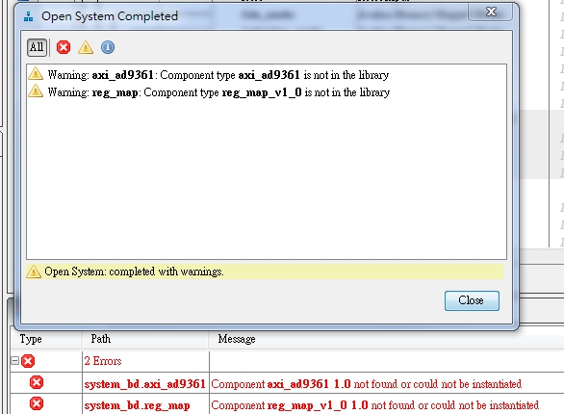

Now start to set the IP Search Path!! Open Setting Dialog in menu **Tools/Options**

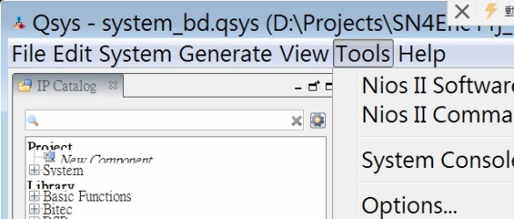

Add two Paths by clicking Add button.

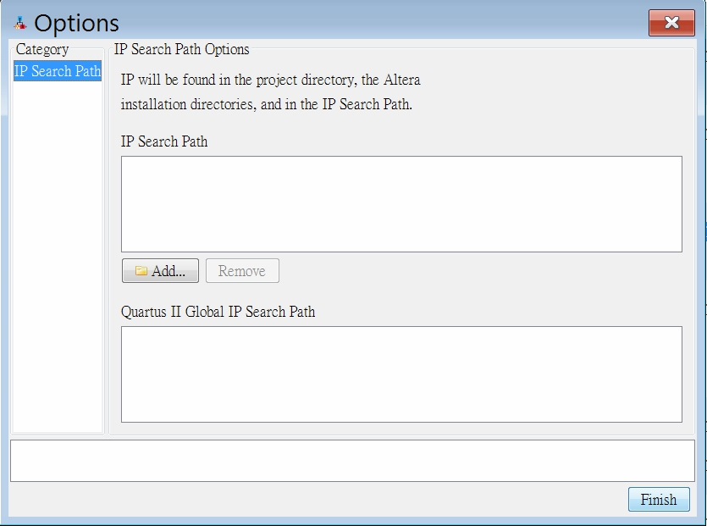

Select the library *axi_ad9361* and *reg_map*

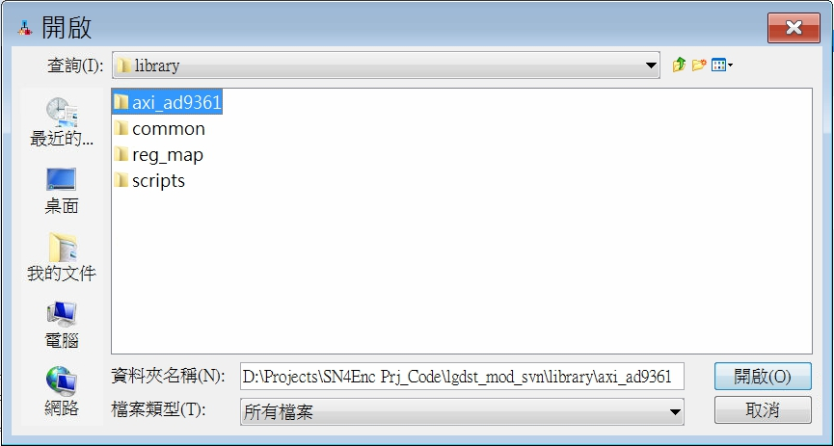

The resulting IP Search Path is as below.

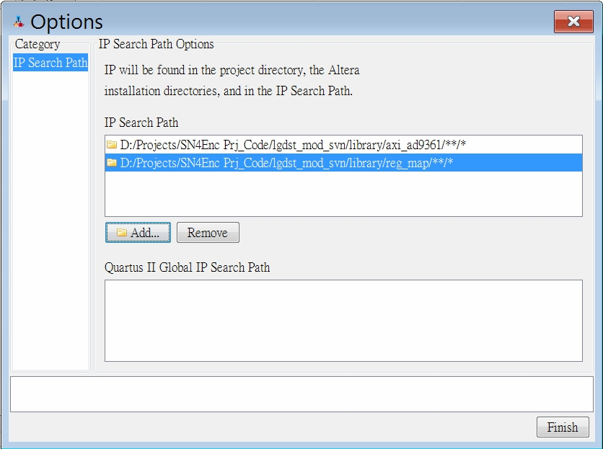

Click “*Generate HDL …*”

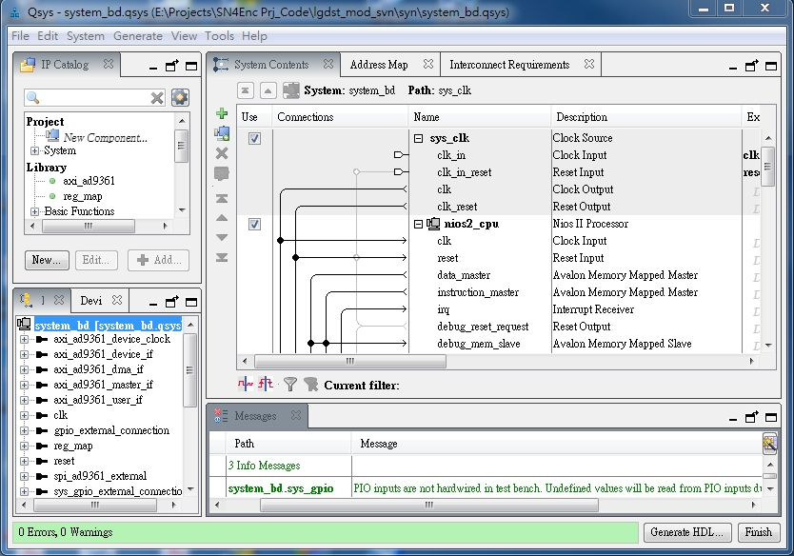

After HDL is generated, Close QSys Tools and restart Fitting.

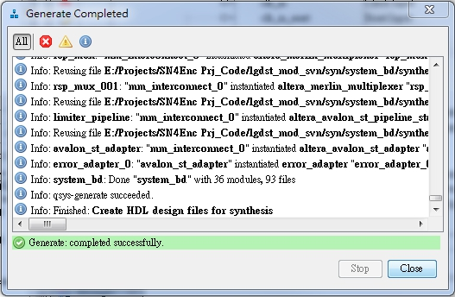

# Instructions for programming Cyclone V PROM

1. Environment Check

Make sure the Configuration Setting is in AS mode

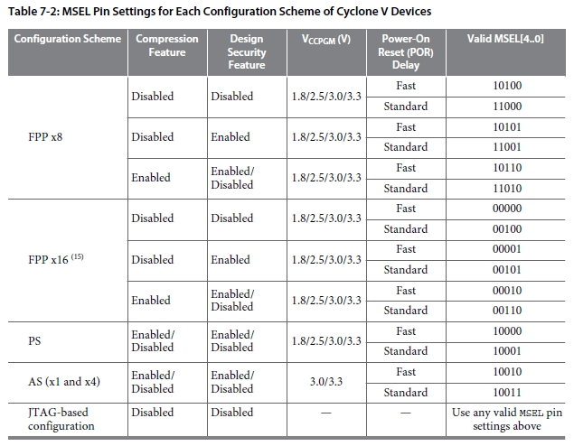

**lgdst_mod** pin and assembly setting:

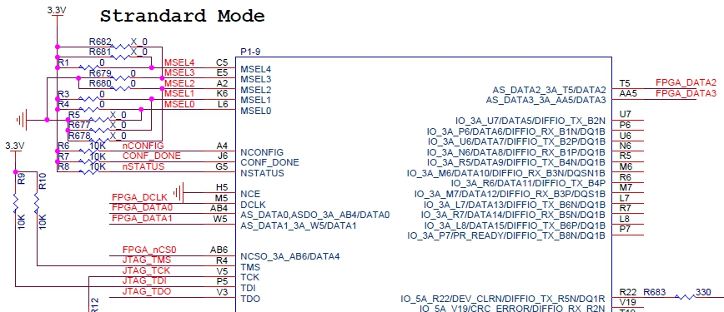

Integrate IP Core “Altera Serial Flash Loader”

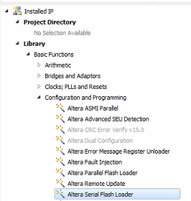

In this example we generate an IP “**named c5_sfl**”.

DO NOT check “Share ASMI interface with your design” and

Generate HDL and then finish

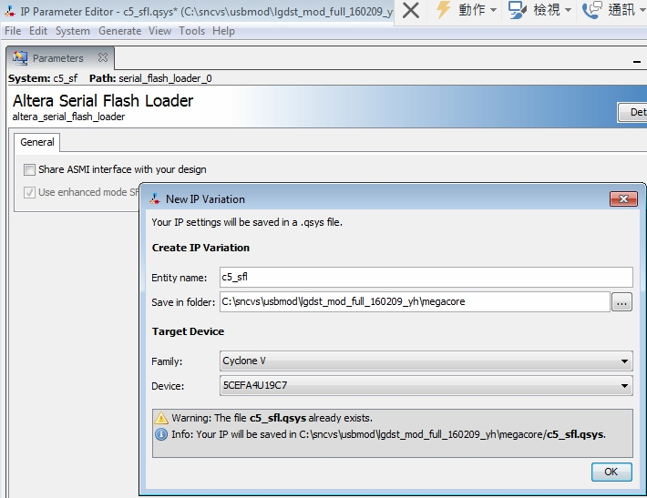

Manually add two files into project: c5_sfl.qip and c5_sfl_qsys

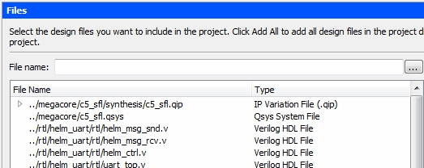

After Fitting you will see the module in Entity List

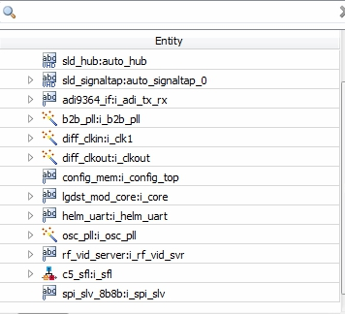

1. Programming Steps
   1. Prepare programming files:

Open Device setting by selecting Assigments/Device…

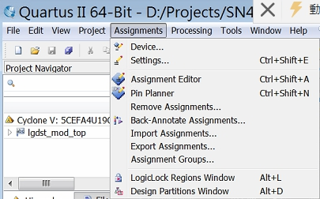

Select the button Device and Pin Options…

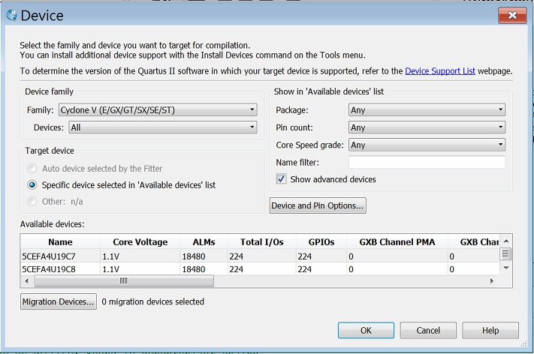

Select Configuration Scheme as “Active Serial x4” or “Active Serial x1”

DO Not Check: “Use configuration devices”

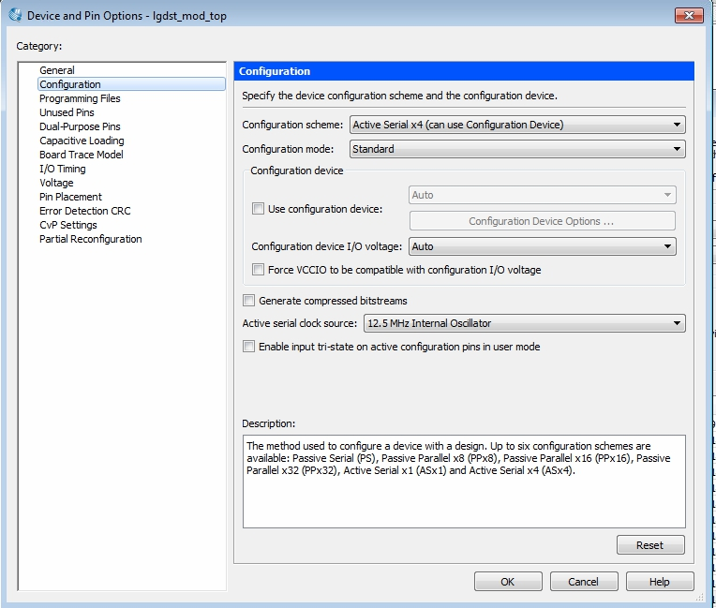

*Regenerate the programming file by restart fitting*

* 1. Convert Programming files

Open Convert Dialog from menu File\Convert Programming Files…

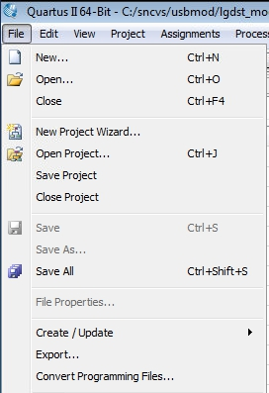

Convert sof file to jic file according the following setting

* Programming file type: JTAG Indiect Configuration File (.jic)
* Configuration device: EPCQ256
* File name: output_files/filename.jic
* Select Flash Loader and the button “Add Device..” becomes active

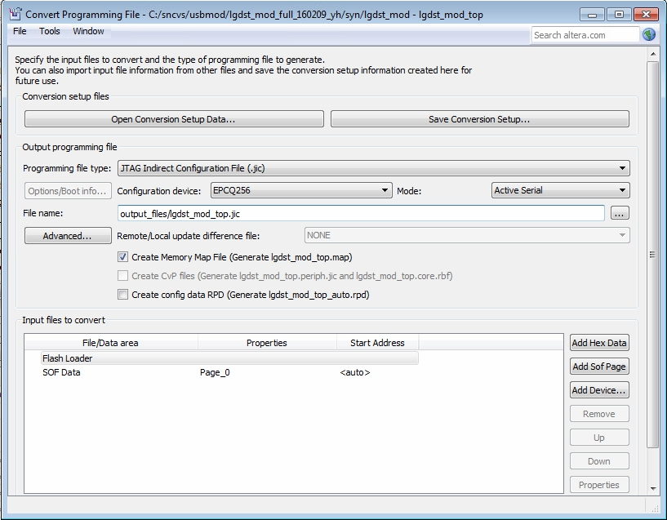

Click button “Add Device…” and selection the FPGA device we used.

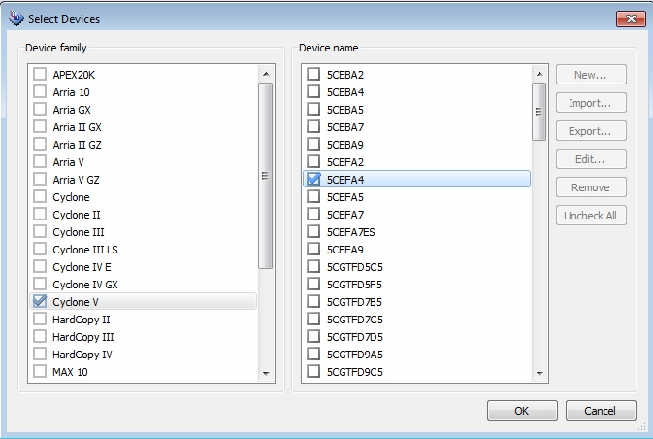

Selection SOF Data and click button “Add File …”

A dialog will popup to select the latest *.sof file

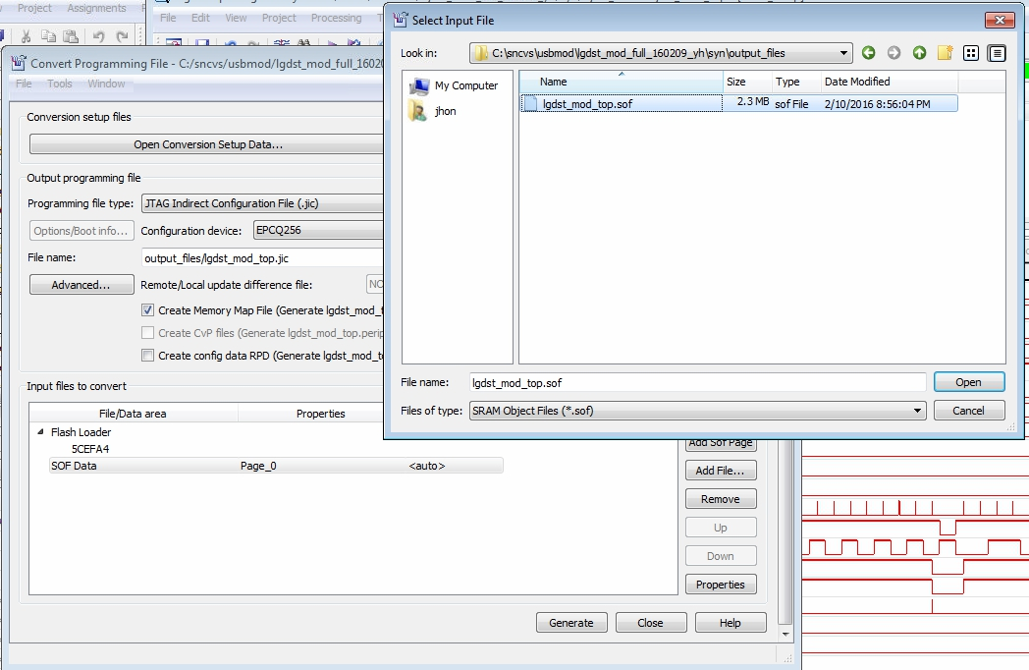

The resulting window is shown as below and press Generate to generate jic file.

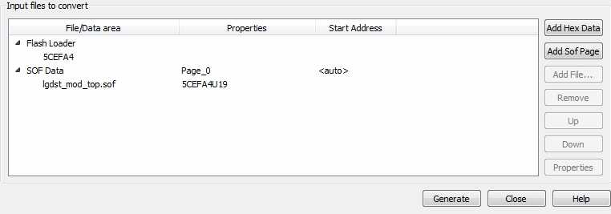

* 1. Programming

Open Programmer and press button “Add File …”

Select the *.jic file you generated and click OPEN

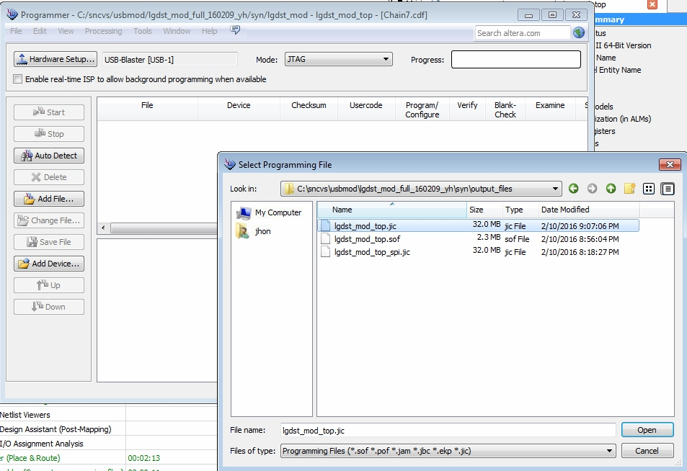

The Programmer shows as below and check the item Program/Configure

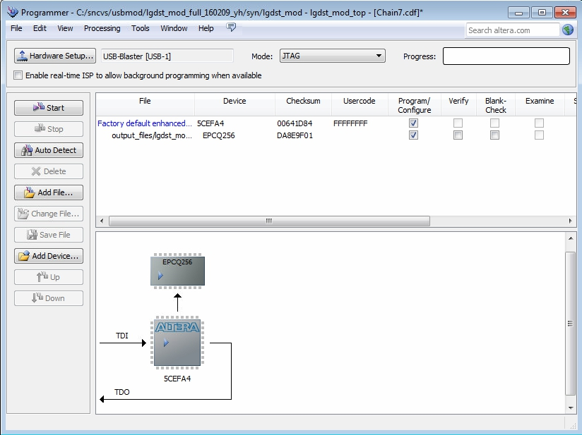

Good luck for your programming!!